Week 11 Assignment

By

Ujjwal Bhasin 200389272

Relational Databases

Maziar Shazari

Step 1.

CREATE DATABASE Week_11_assignment;

# Dump of table my_contacts

# ------------------------------------------------------------

CREATE TABLE `my_contacts` (

`last_name` varchar(30) ,

`first_name` varchar(20) ,

`email` varchar(50) ,

`gender` char(1),

`birthday` date ,

`profession` varchar(50),

`location` varchar(50),

`status` varchar(20),

`interests` varchar(100),

`seeking` varchar(100)

) ENGINE=InnoDB DEFAULT CHARSET=latin1;

INSERT INTO `my_contacts` (`last_name`,`first_name`,`email`,`gender`,`birthday`,`profession`,`location`,`status`,`interests`,`seeking`) VALUES ('Anderson','Jillian','jill_anderson@ \nbreakneckpizza.com','F','1980-09-05','Technical Writer','Palo Alto, CA','single','kayaking, reptiles','relationship, friends');

INSERT INTO `my_contacts` (`last_name`,`first_name`,`email`,`gender`,`birthday`,`profession`,`location`,`status`,`interests`,`seeking`) VALUES ('Kenton','Leo','lkenton@starbuzzcoffee.com','M','1974-01-10','Manager','San Francisco, CA','divorced','women','women to date');

INSERT INTO `my_contacts` (`last_name`,`first_name`,`email`,`gender`,`birthday`,`profession`,`location`,`status`,`interests`,`seeking`) VALUES ('McGavin','Darrin',' captainlove@headfirsttheater.com','M','1966-01-23','Cruise Ship Captain','San Diego, CA','single','sailing, fishing, yachting','women for casual relationships');

INSERT INTO `my_contacts` (`last_name`,`first_name`,`email`,`gender`,`birthday`,`profession`,`location`,`status`,`interests`,`seeking`) VALUES ('Franklin','Joe','joe_franklin@leapinlimos.com','M','1977-04-28','Software Sales','Dallas, TX','married','fishing, drinking','new job');

INSERT INTO `my_contacts` (`last_name`,`first_name`,`email`,`gender`,`birthday`,`profession`,`location`,`status`,`interests`,`seeking`) VALUES ('Hamilton','Jamie','dontbother@starbuzzcoffee.com','F','1964-09-10','System Administrator','Princeton, NJ','married','RPG','nothing');

INSERT INTO `my_contacts` (`last_name`,`first_name`,`email`,`gender`,`birthday`,`profession`,`location`,`status`,`interests`,`seeking`) VALUES ('Chevrolet','Maurice','bookman4u@objectville.net','M','1962-07-01','Bookshop Owner','Mountain View, CA','married','collecting books, scuba diving','friends');

INSERT INTO `my_contacts` (`last_name`,`first_name`,`email`,`gender`,`birthday`,`profession`,`location`,`status`,`interests`,`seeking`) VALUES ('Kroger','Renee','poorrenee@mightygumball.net','F','1976-12-03','Unemployed','San Francisco, CA','divorced','cooking','employment');

INSERT INTO `my_contacts` (`last_name`,`first_name`,`email`,`gender`,`birthday`,`profession`,`location`,`status`,`interests`,`seeking`) VALUES ('Mendoza','Angelina','angelina@starbuzzcoffee.com','F','1979-08-19','UNIX Sysadmin','San Francisco, CA','married','acting, dancing','new job');

INSERT INTO `my_contacts` (`last_name`,`first_name`,`email`,`gender`,`birthday`,`profession`,`location`,`status`,`interests`,`seeking`) VALUES ('Murphy','Donald','padraic@tikibeanlounge.com','M','1967-01-23','Computer Programmer','New York City, NY','committed relationsh','RPG, anime','friends');

INSERT INTO `my_contacts` (`last_name`,`first_name`,`email`,`gender`,`birthday`,`profession`,`location`,`status`,`interests`,`seeking`) VALUES ('Spatner','John','jpoet@objectville.net','M','1963-04-18','Salesman','Woodstock, NY','married','poetry, screenwriting','nothing');

INSERT INTO `my_contacts` (`last_name`,`first_name`,`email`,`gender`,`birthday`, `profession`,`location`) VALUES ('Toth','Anne','Anne_Toth@leapinlimos.com','F','1969-11-18', 'Artist','San Fran, CA');

INSERT INTO `my_contacts` (`last_name`,`first_name`,`email`,`gender`,`birthday`, `profession`,`location`) VALUES ('Manson','Anne','am86@objectville.net','F','1977-08-09', 'Baker','Seattle, WA');

INSERT INTO `my_contacts` (`last_name`,`first_name`,`email`,`gender`,`birthday`, `profession`,`location`) VALUES ('Hardy','Anne','anneh@b0tt0msup.com','F','1963-04-18', 'Teacher','San Fran, CA');

INSERT INTO `my_contacts` (`last_name`,`first_name`,`email`,`gender`,`birthday`, `profession`,`location`) VALUES ('Parker','Anne','annep@starbuzzcoffee.com','F','1983-01-10', 'Student','San Fran, CA');

INSERT INTO `my_contacts` (`last_name`,`first_name`,`email`,`gender`,`birthday`, `profession`,`location`) VALUES ('Blunt','Anne','anneblunt@breakneckpizza.com','F','1959-10-09', 'Web Designer','San Fran, CA');

INSERT INTO `my_contacts` (`last_name`,`first_name`,`email`,`gender`,`birthday`, `profession`,`location`) VALUES ('Jacobs','Anne','anne99@objectville.net','F','1968-02-05', 'Computer Programmer','San Jose, CA');

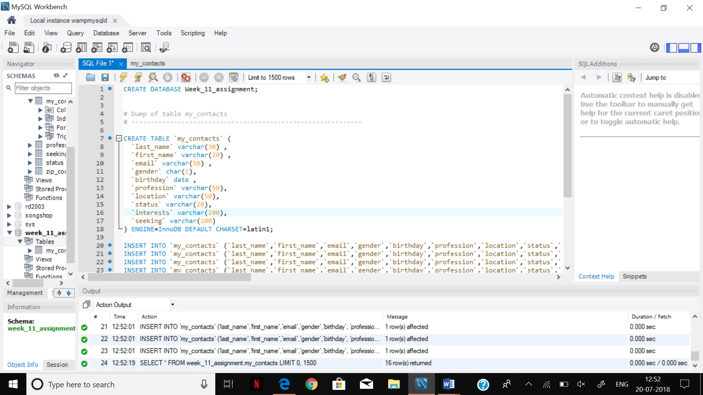

ALTER TABLE my_contacts

ADD column contact_id INT(11) NOT NULL auto_increment PRIMARY KEY FIRST;

SELECT contact_id, first_name,last_name , profession, interests, seeking, status, location From my_contacts;

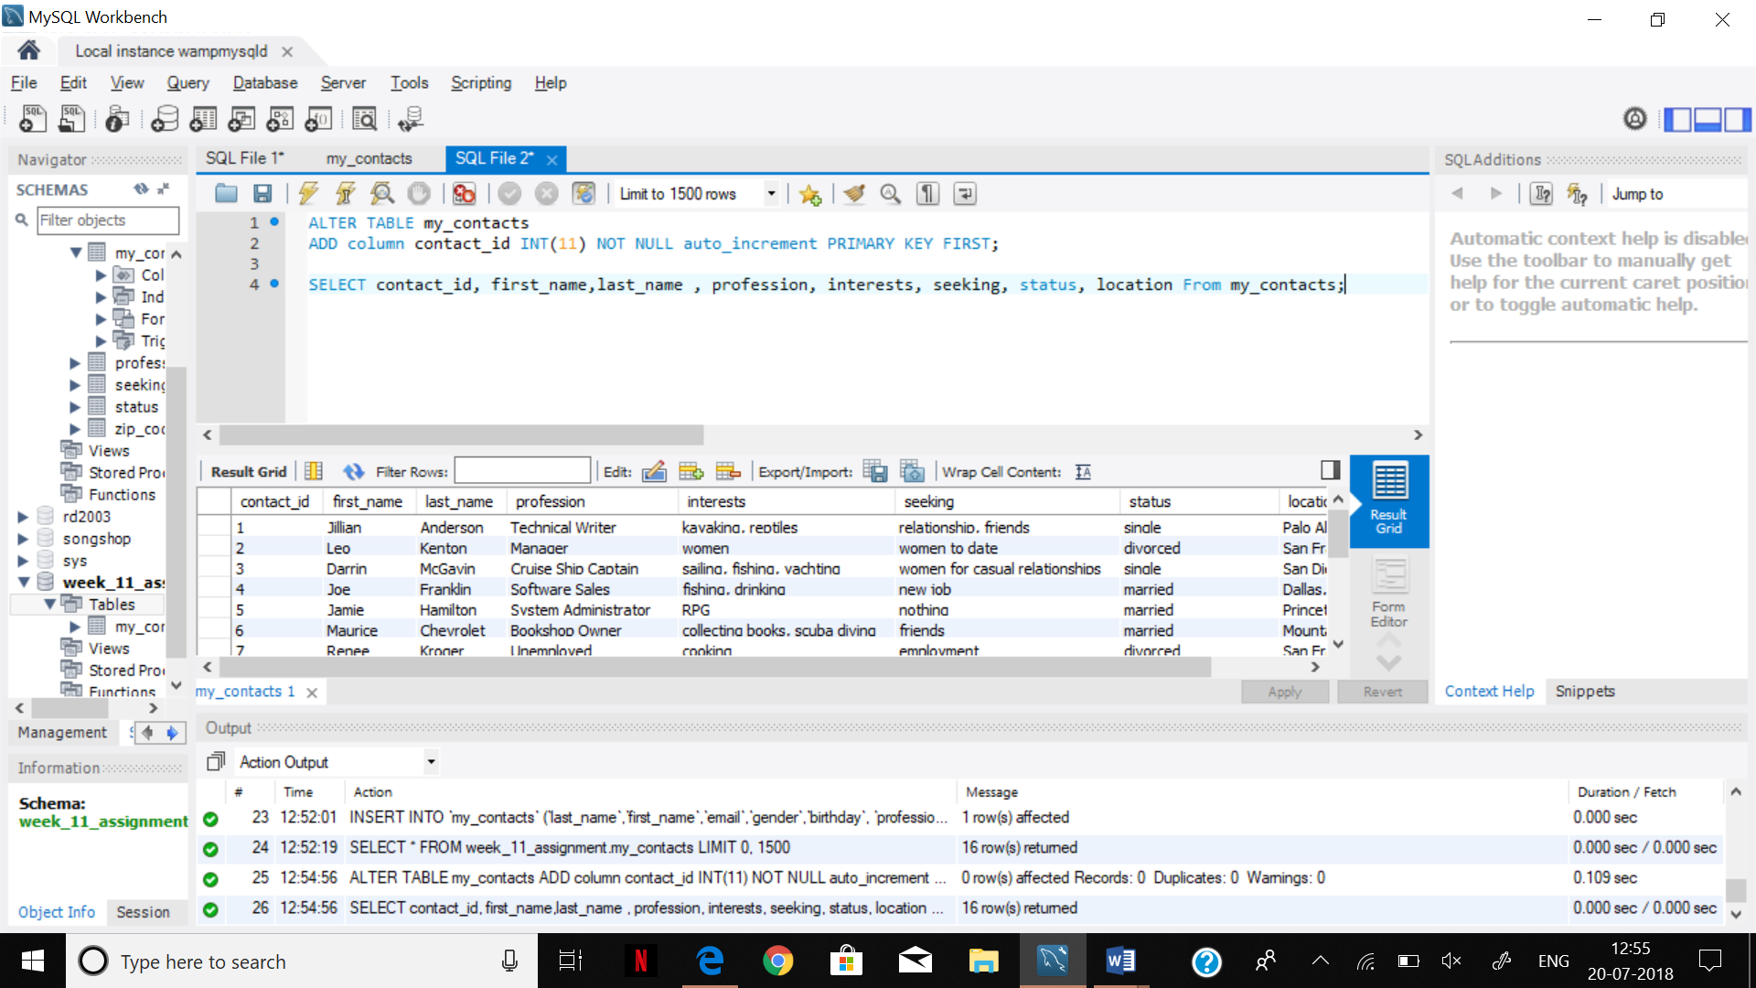

Step 2.

INSERT INTO my_contacts VALUES (17,'Ujjwal','Bhasin','ub@gmail.com','M','1999-07-30','Computer Programmer','Toronto, ON','Single','gymming','degree in Computer Science');

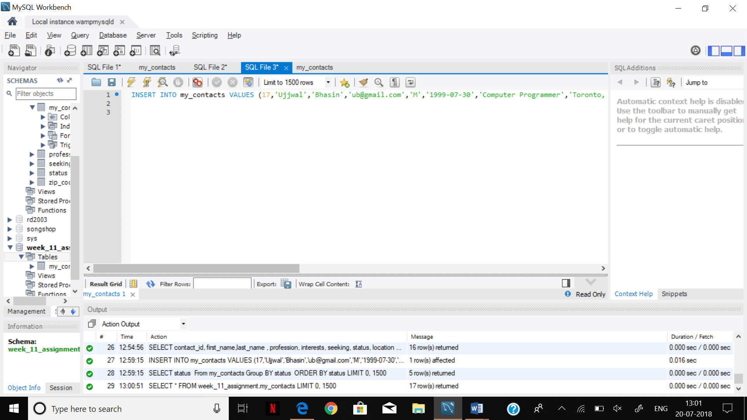

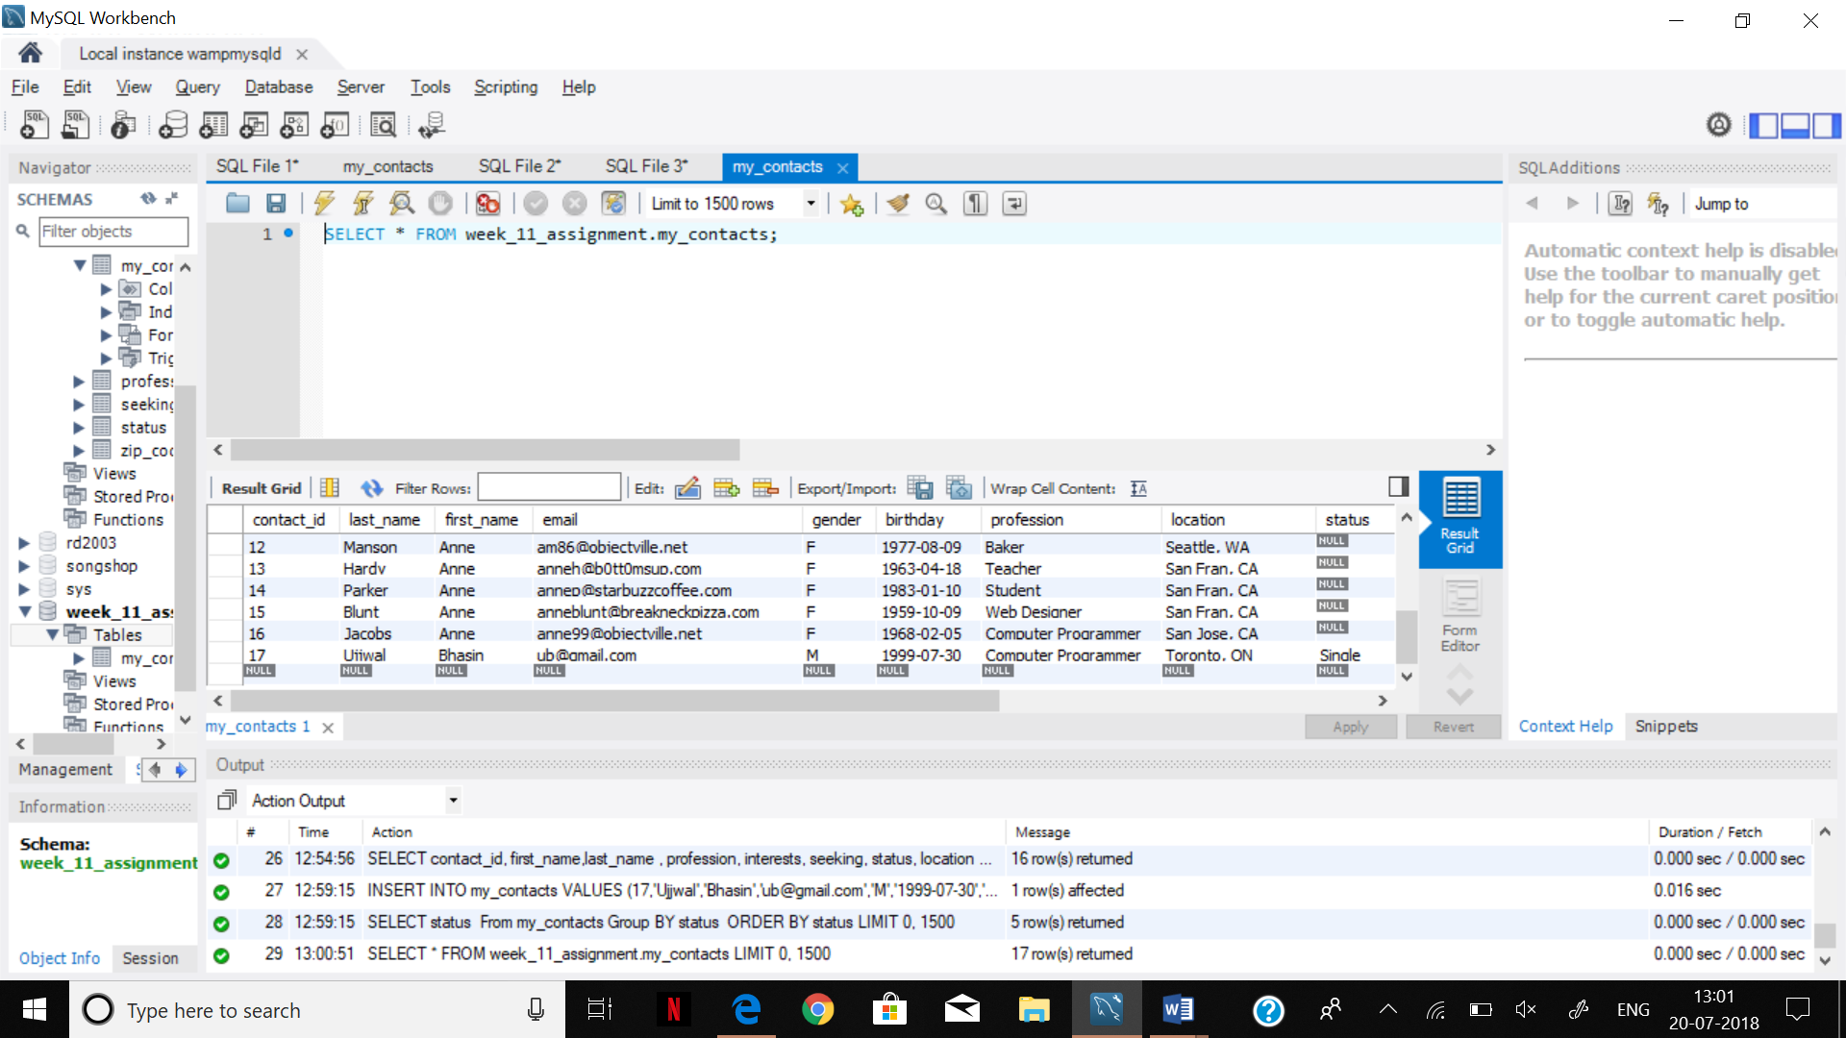

Step 3.

SELECT status

From my_contacts

Group BY status

ORDER BY status;

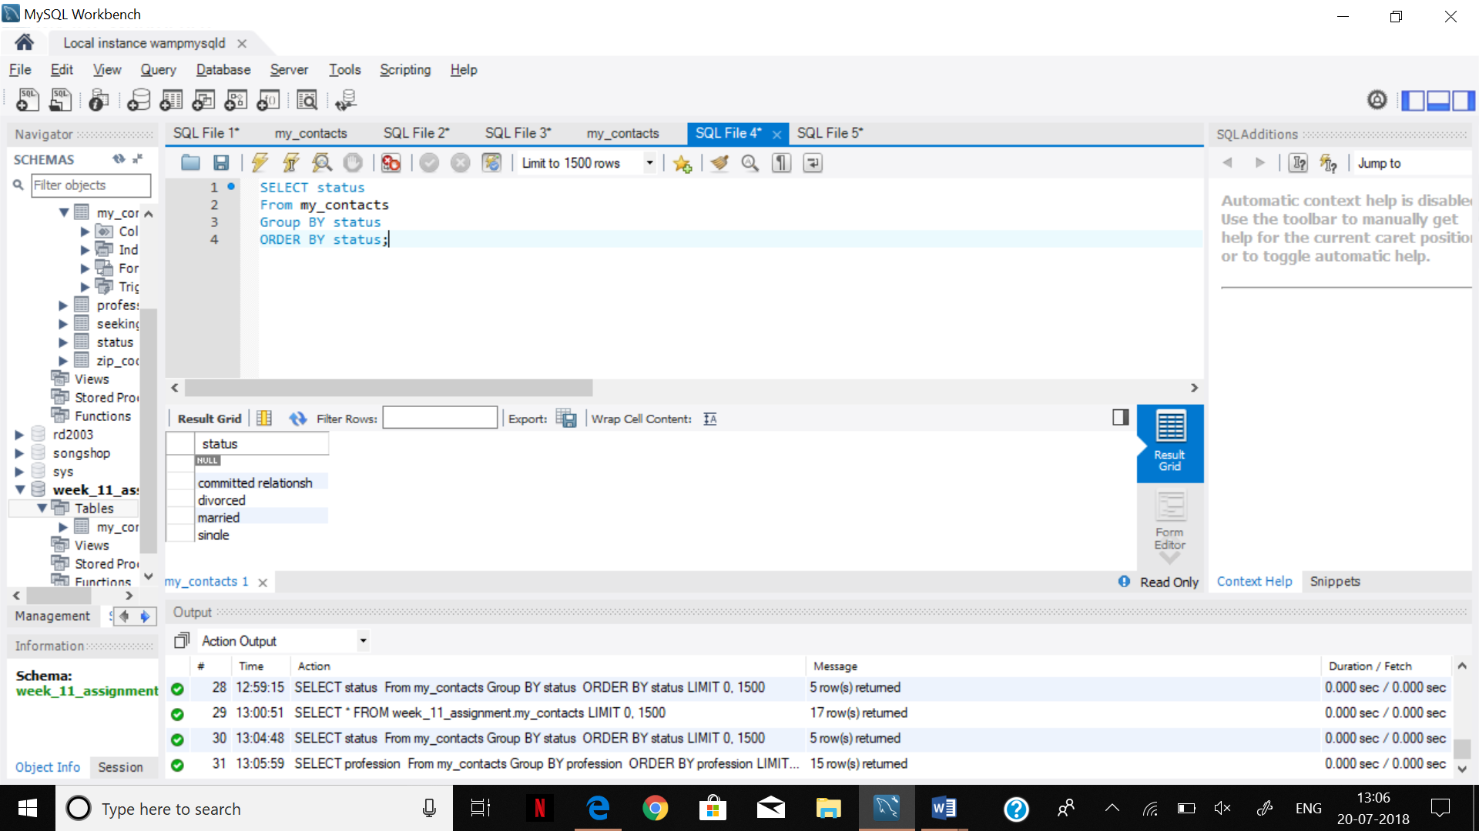

SELECT profession

From my_contacts

Group BY profession

ORDER BY profession;

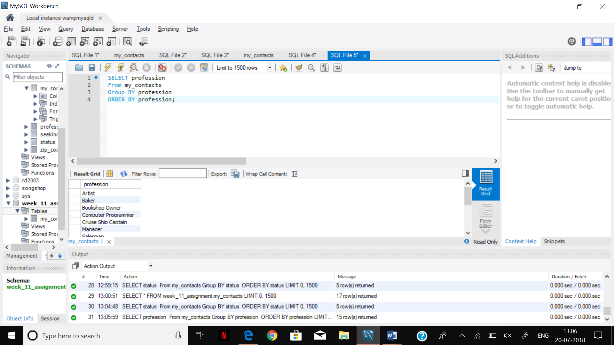

SELECT seeking

From my_contacts

Group BY seeking

ORDER BY seeking;

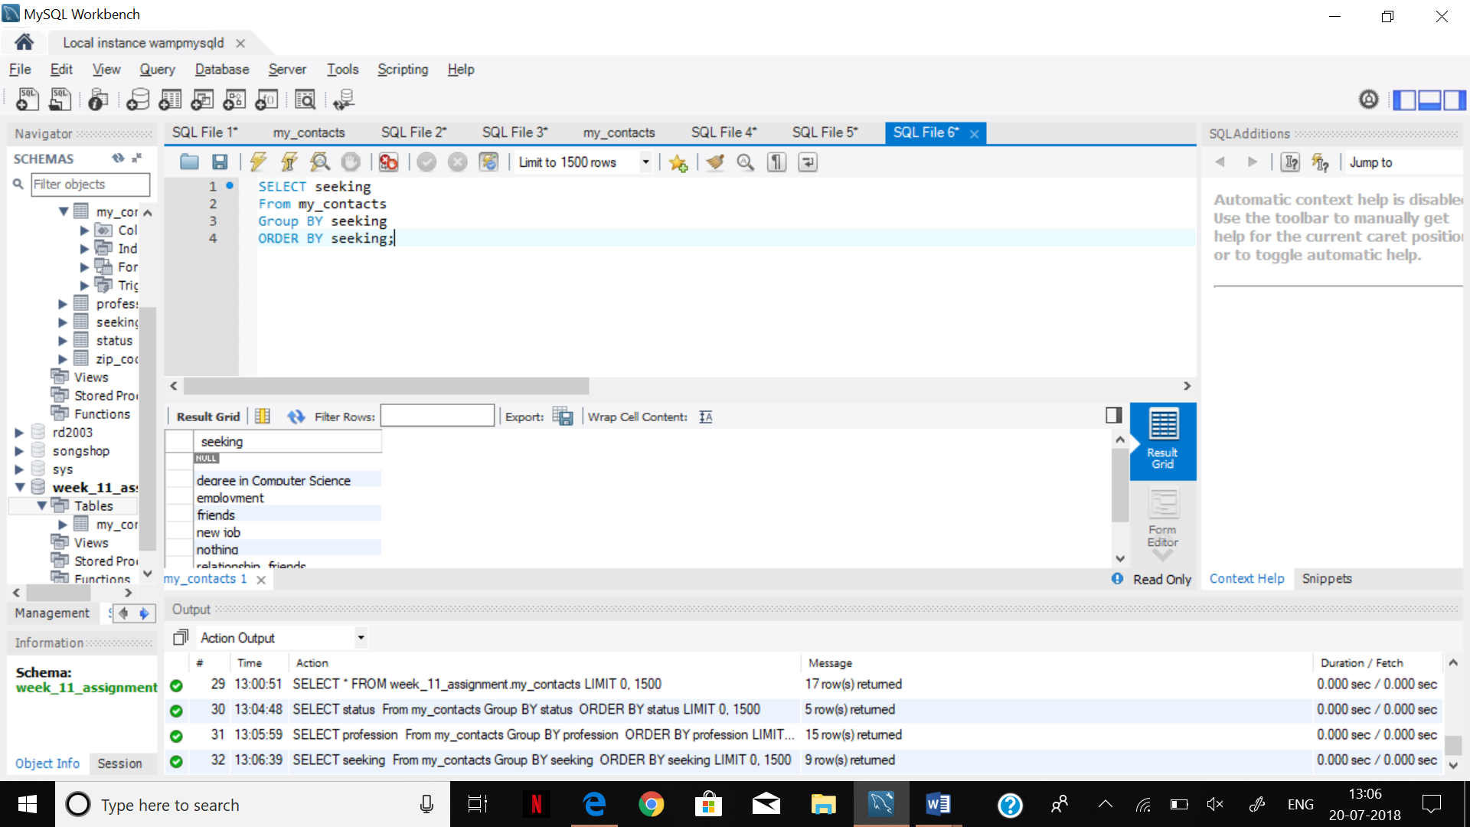

SELECT interests

From my_contacts

Group BY interests

ORDER BY interests;

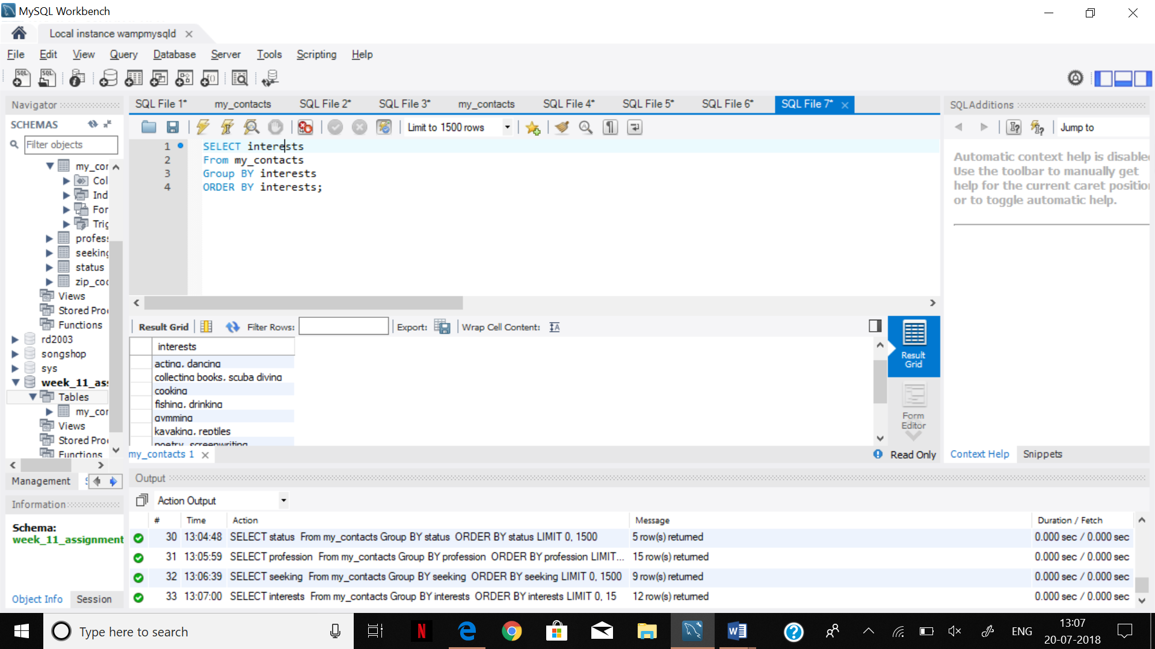

Step 4.

ALTER TABLE my_contacts

ADD (interest1 VARCHAR(20),

interest2 VARCHAR(20),

interest3 VARCHAR(20),

interest4 VARCHAR(20)

);

Select interests,interest1,interest2,interest3,interest4 From my_contacts;

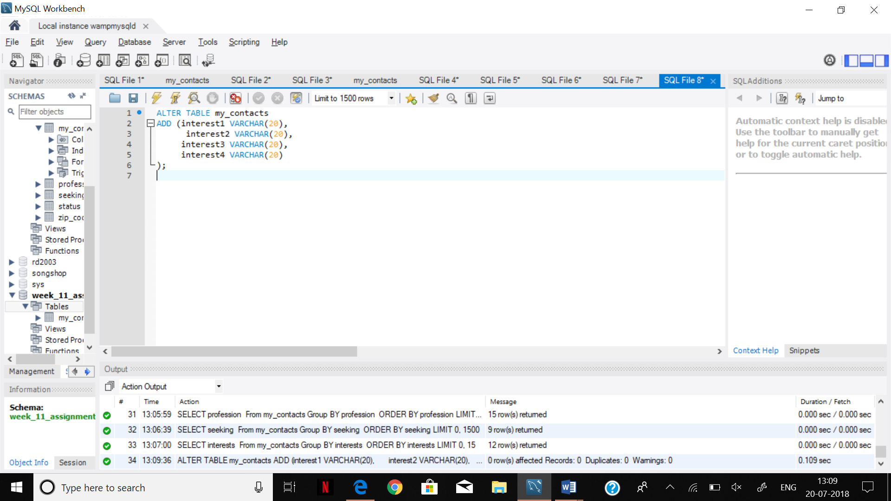

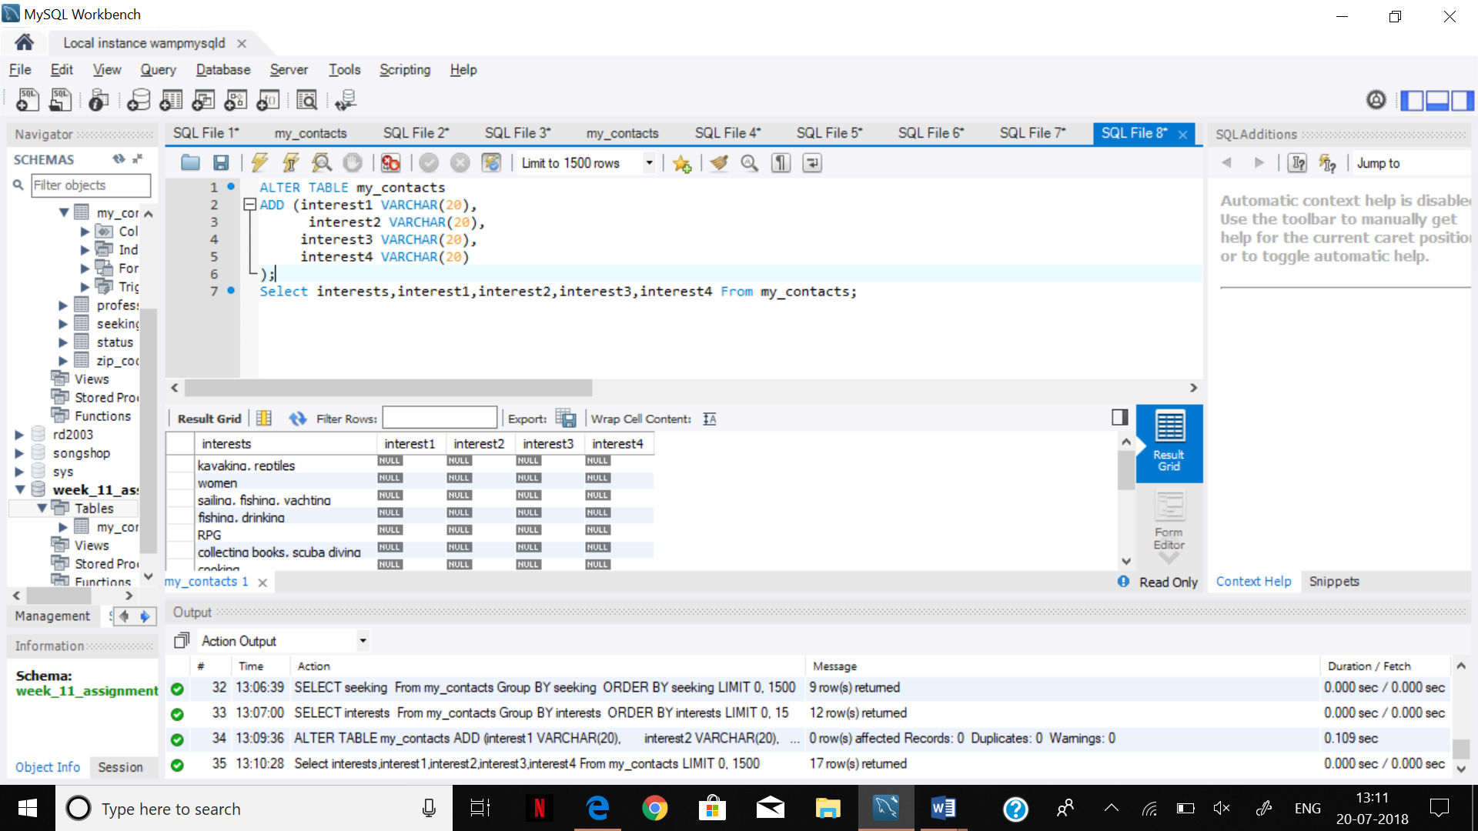

Step 5.

update my_contacts

SET

interest4 = substring_index(interests,',',1);

Select interests,interest1,interest2,interest3,interest4 From my_contacts;

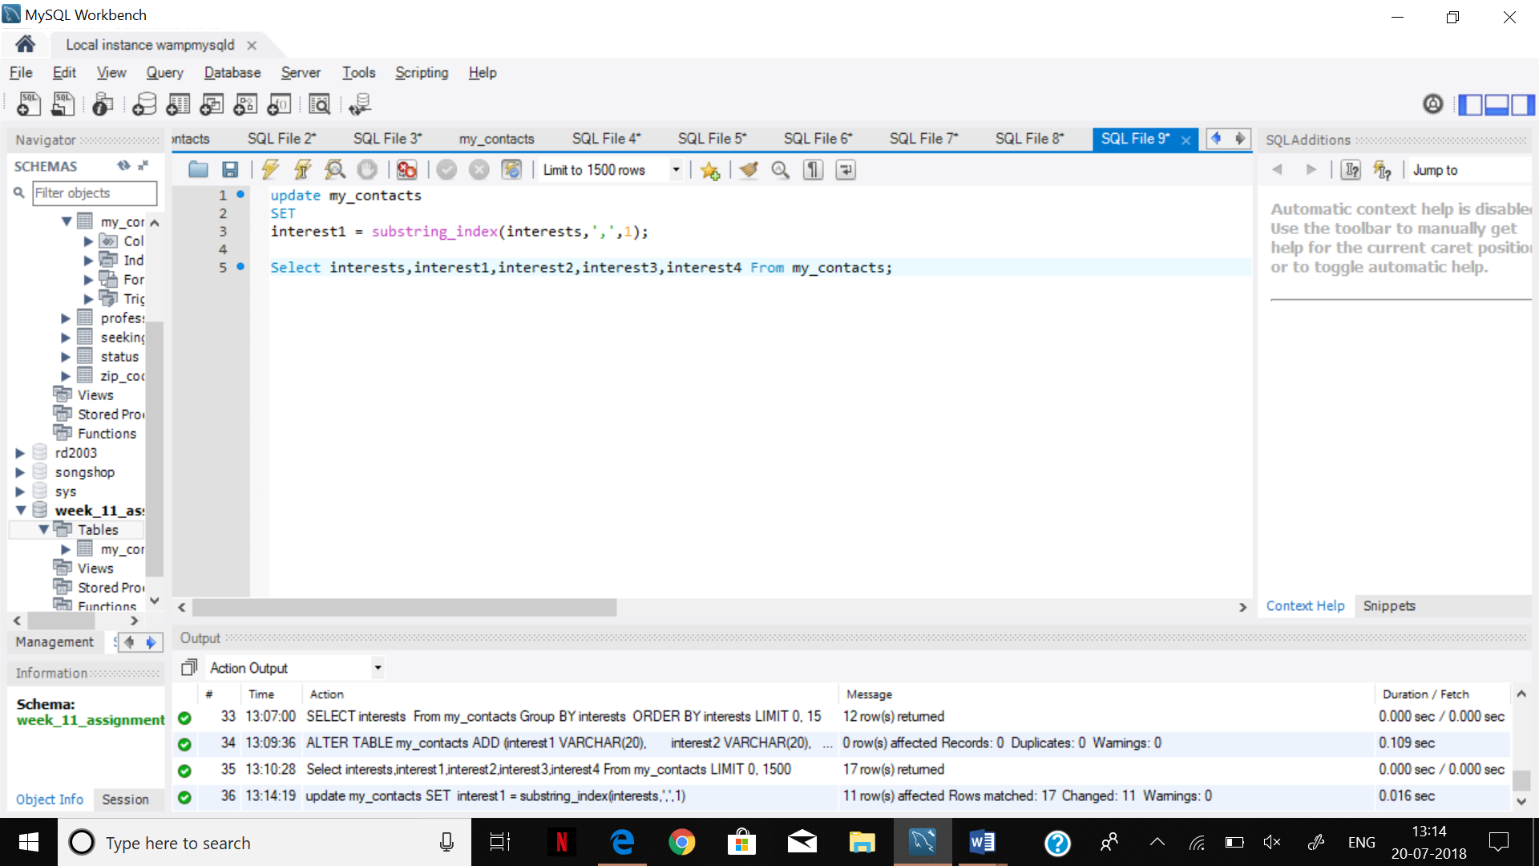

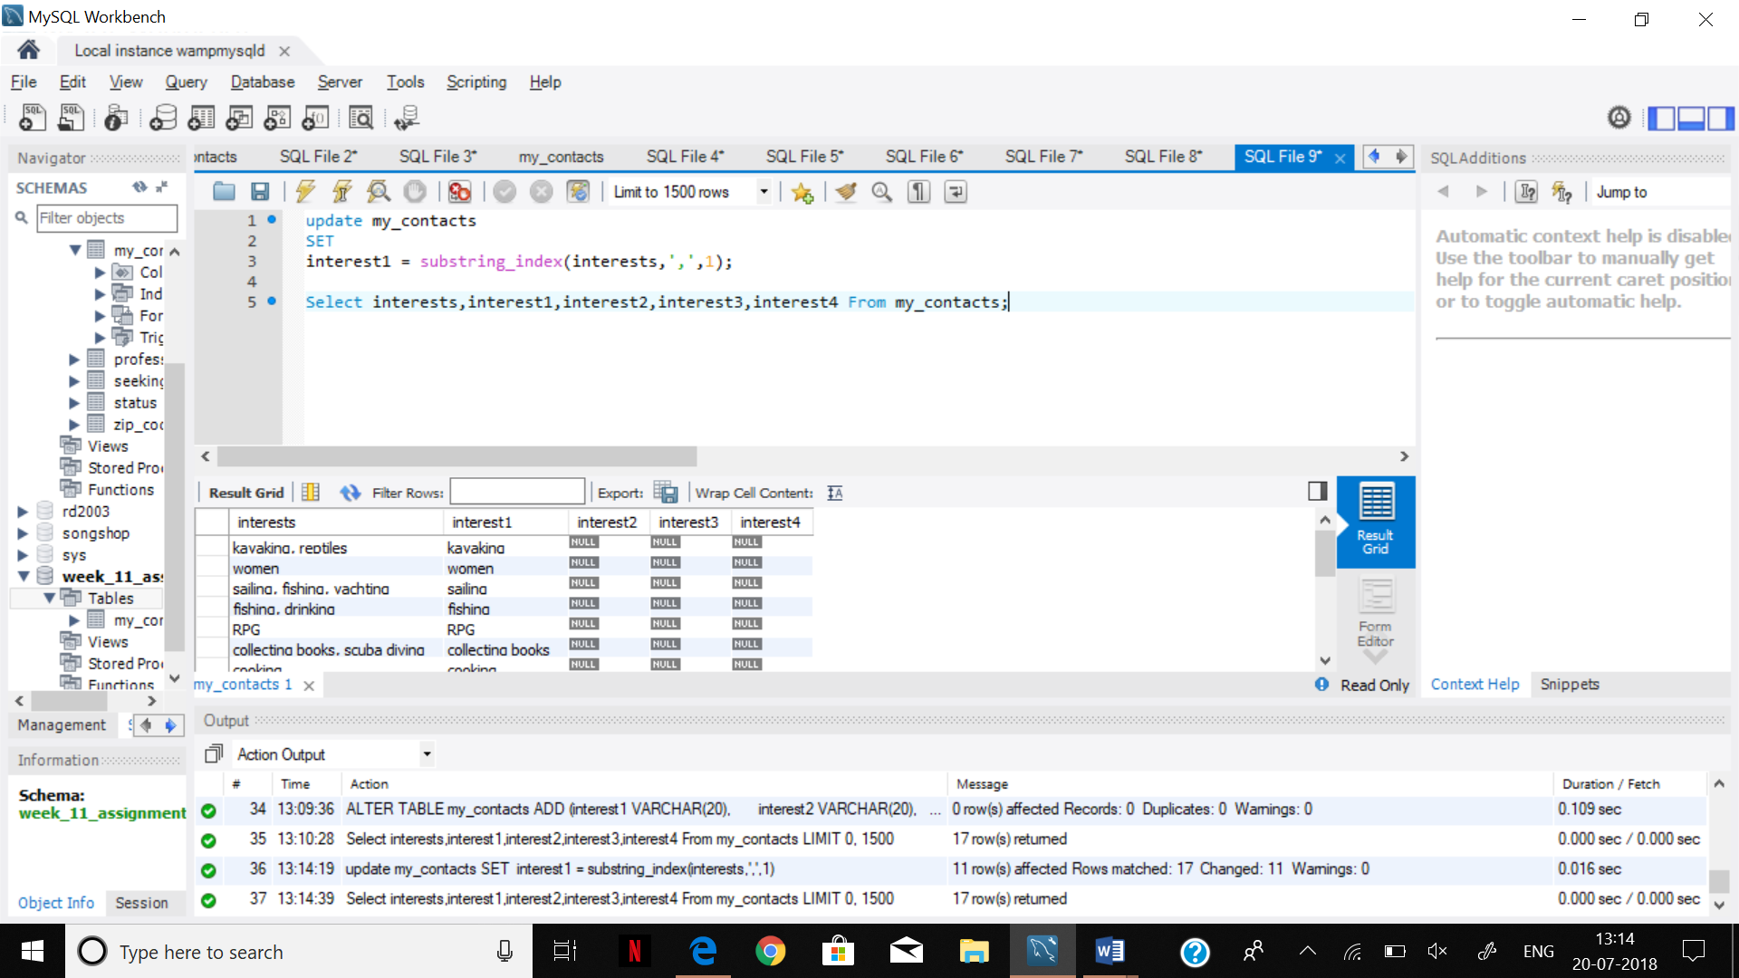

Step 6.

Select interests,interest1,interest2,interest3,interest4 From my_contacts;

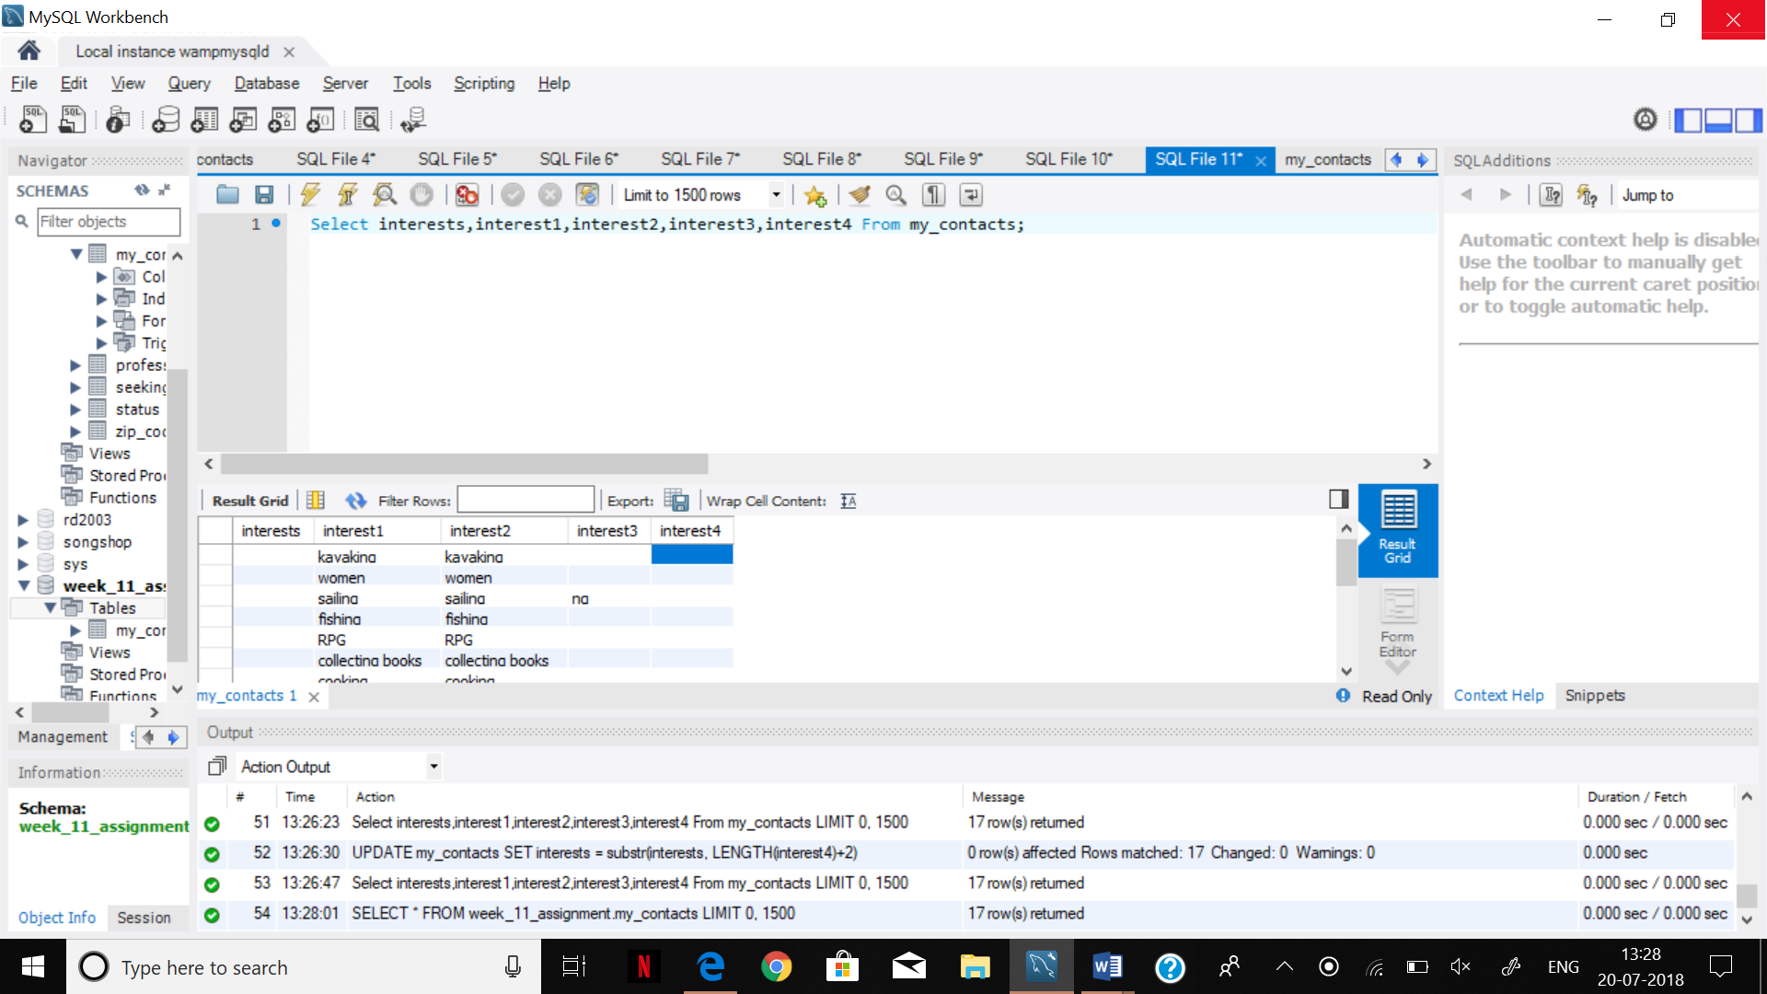

Step 7.

SELECT * FROM week_11_assignment.my_contacts;

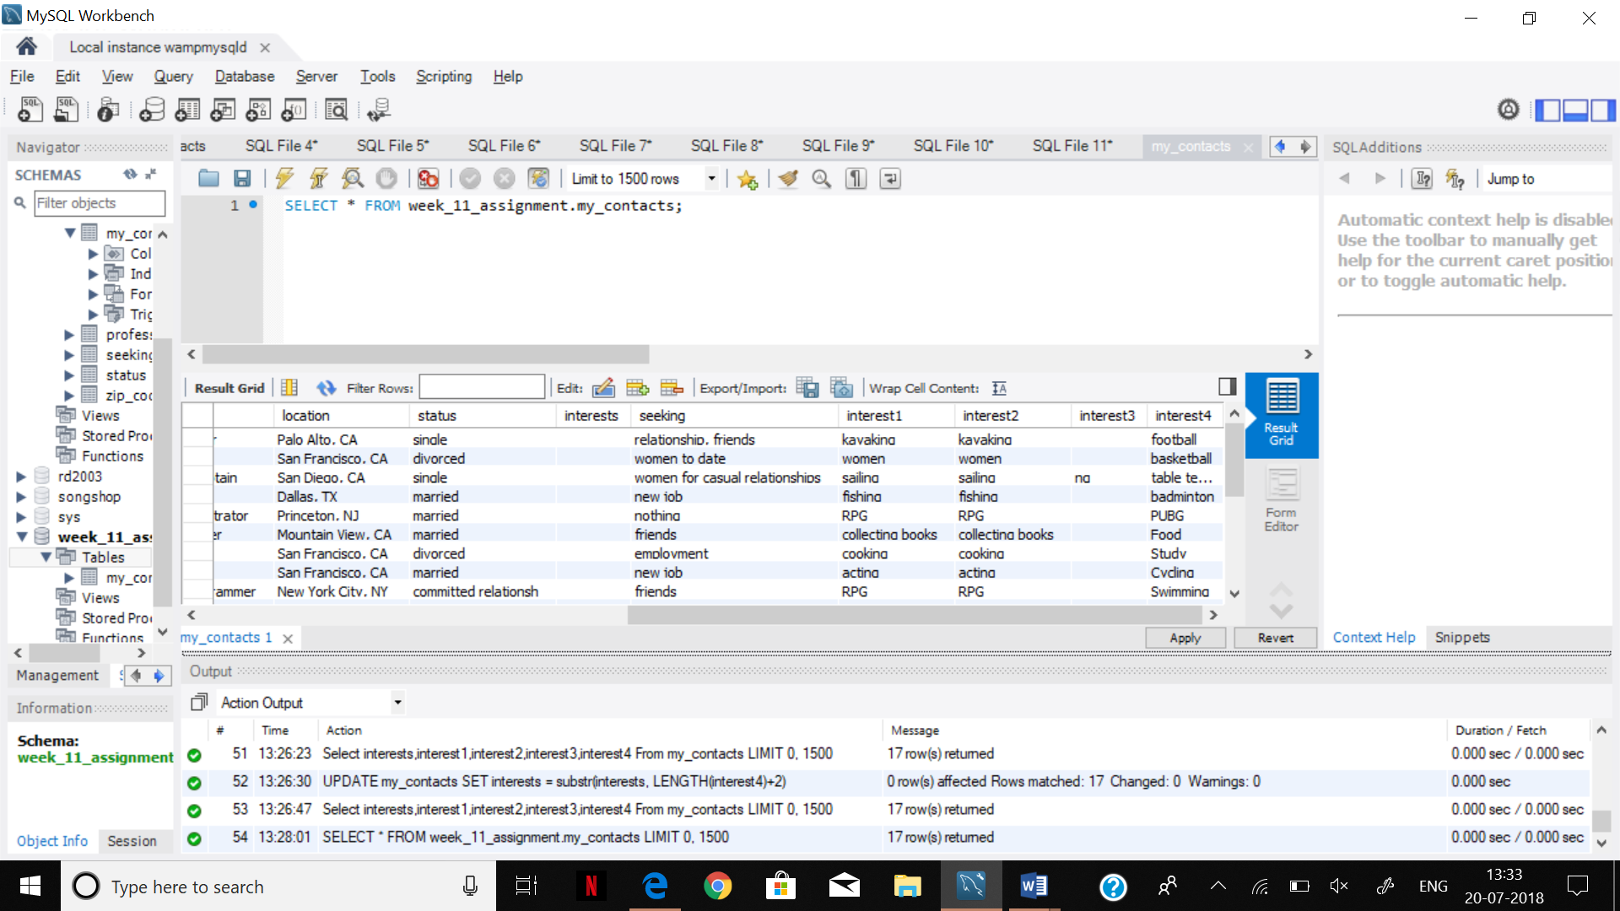

Step 8.

USE week_11_assignment;

CREATE TABLE profession

( id INT(11) NOT NULL AUTO_INCREMENT PRIMARY KEY,

profession VARCHAR(20) );

INSERT INTO profession(profession) SELECT profession FROM my_contacts GROUP BY profession ORDER BY profession;

SELECT * FROM profession;

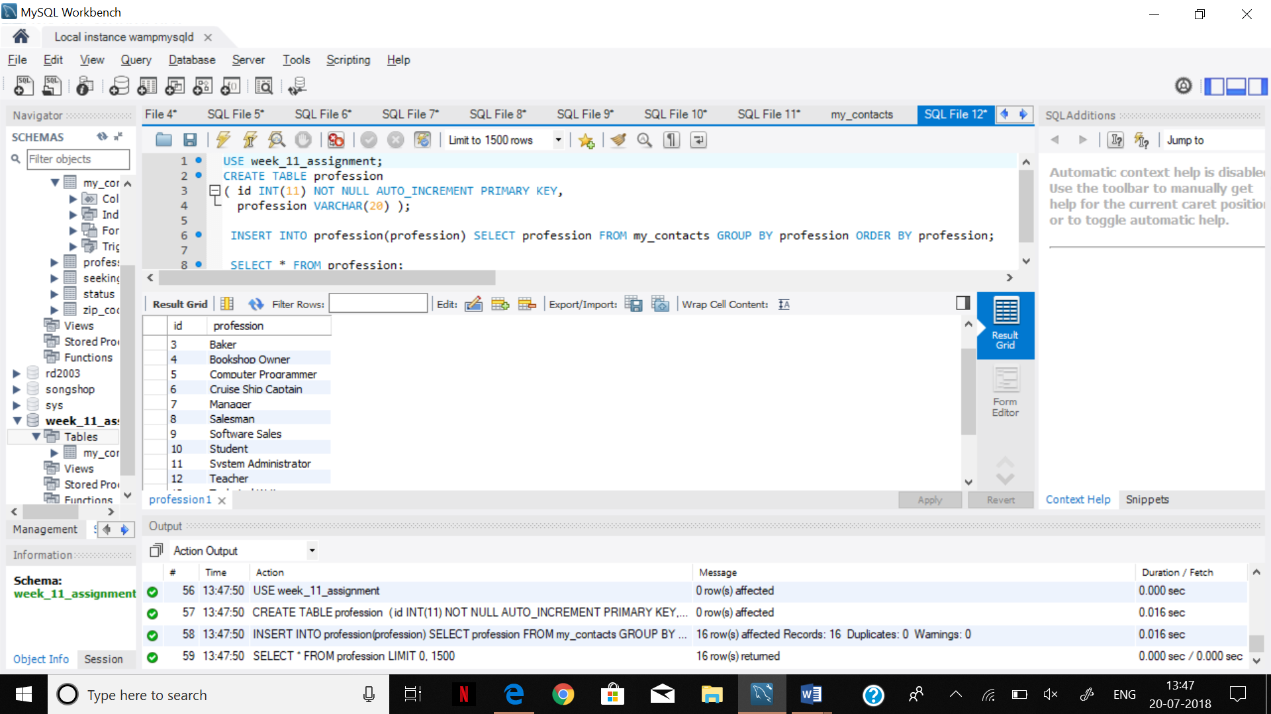

Step 9.

SELECT profession AS mc_prof

FROM my_contacts AS mc

GROUP BY mc_prof

ORDER BY mc_prof;

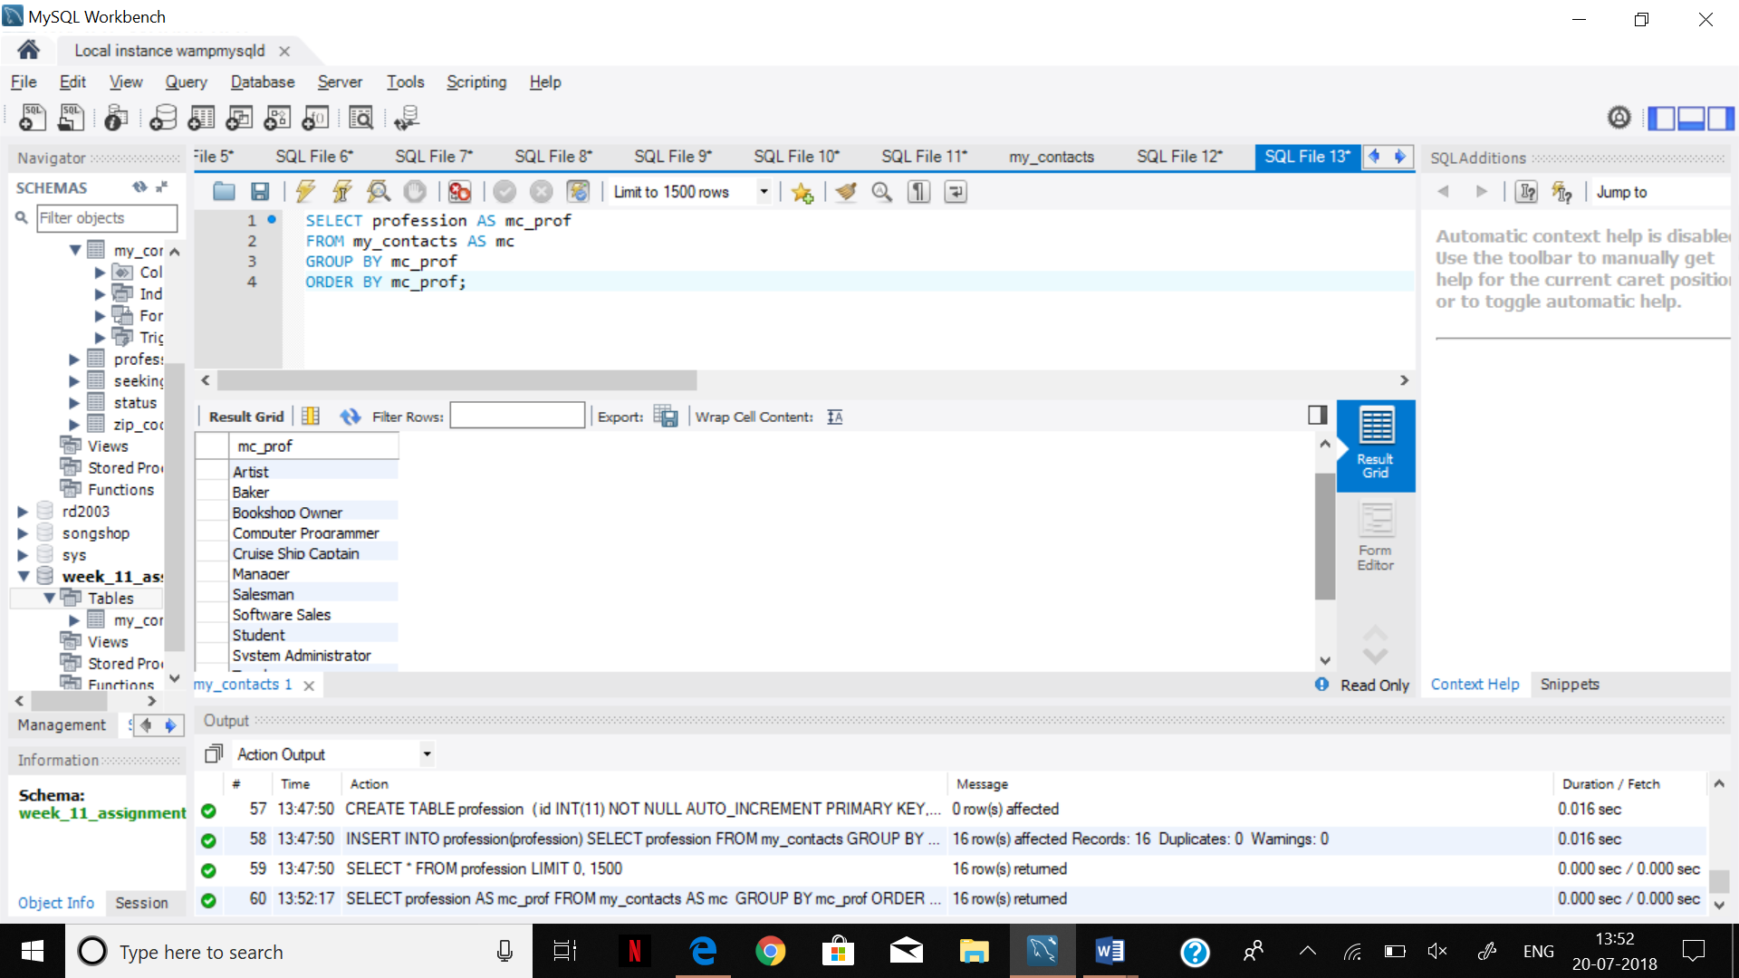

Step 10.

INSERT INTO toys VALUES (1,'hula hoop');

INSERT INTO toys VALUES (2,'balsa glider');

INSERT INTO toys VALUES (3,'toy soldiers');

INSERT INTO toys VALUES (4,'basball cards');

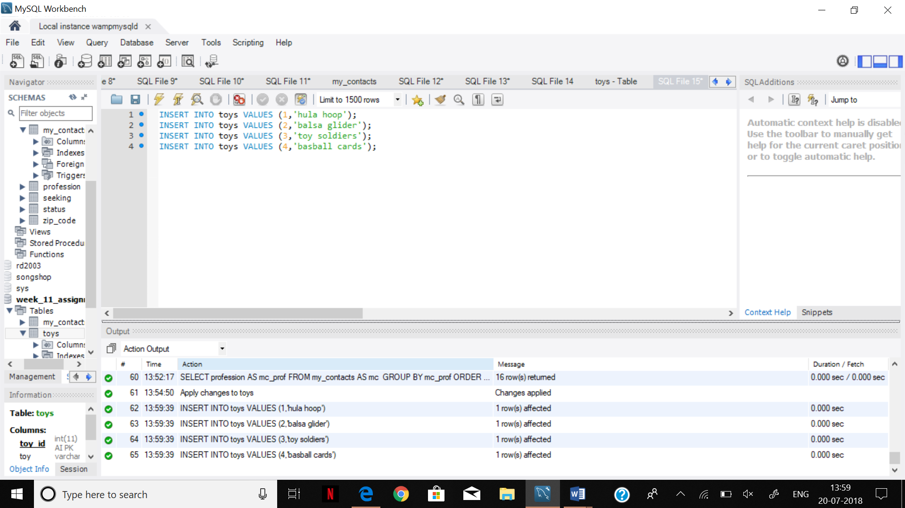

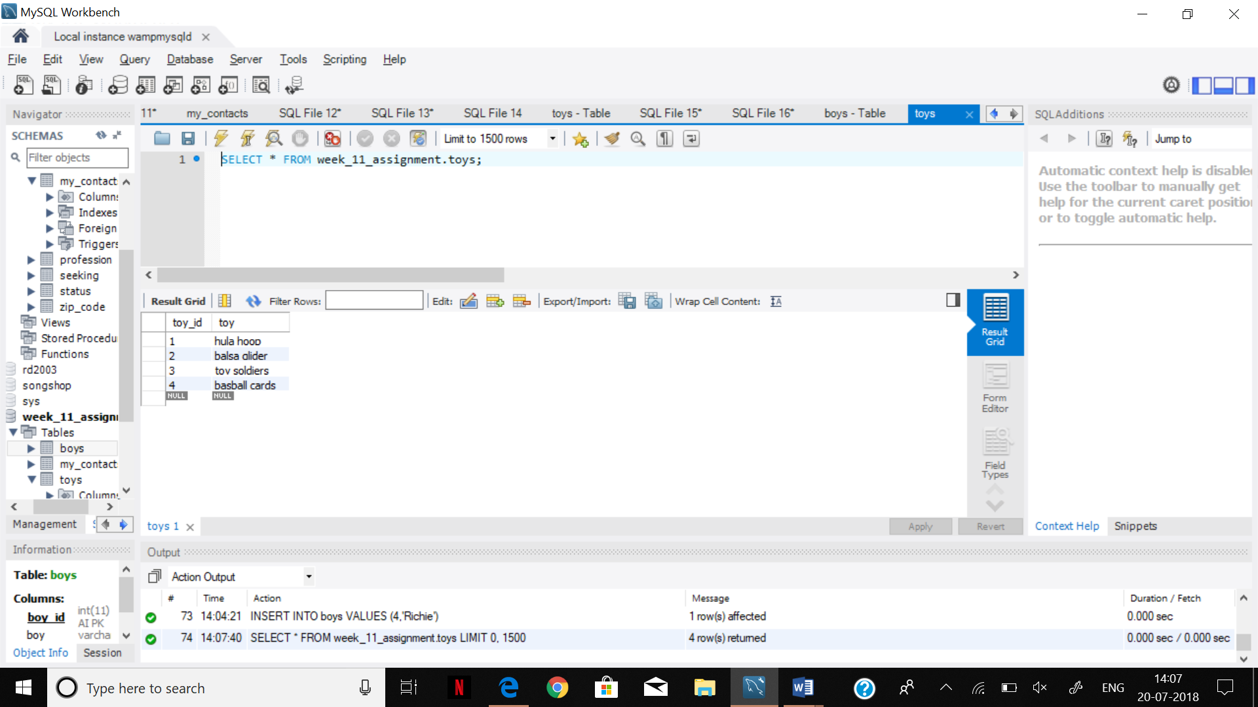

INSERT INTO boys VALUES (1,'Davey');

INSERT INTO boys VALUES (2,'Bobby');

INSERT INTO boys VALUES (3,'Beaver');

INSERT INTO boys VALUES (4,'Richie');

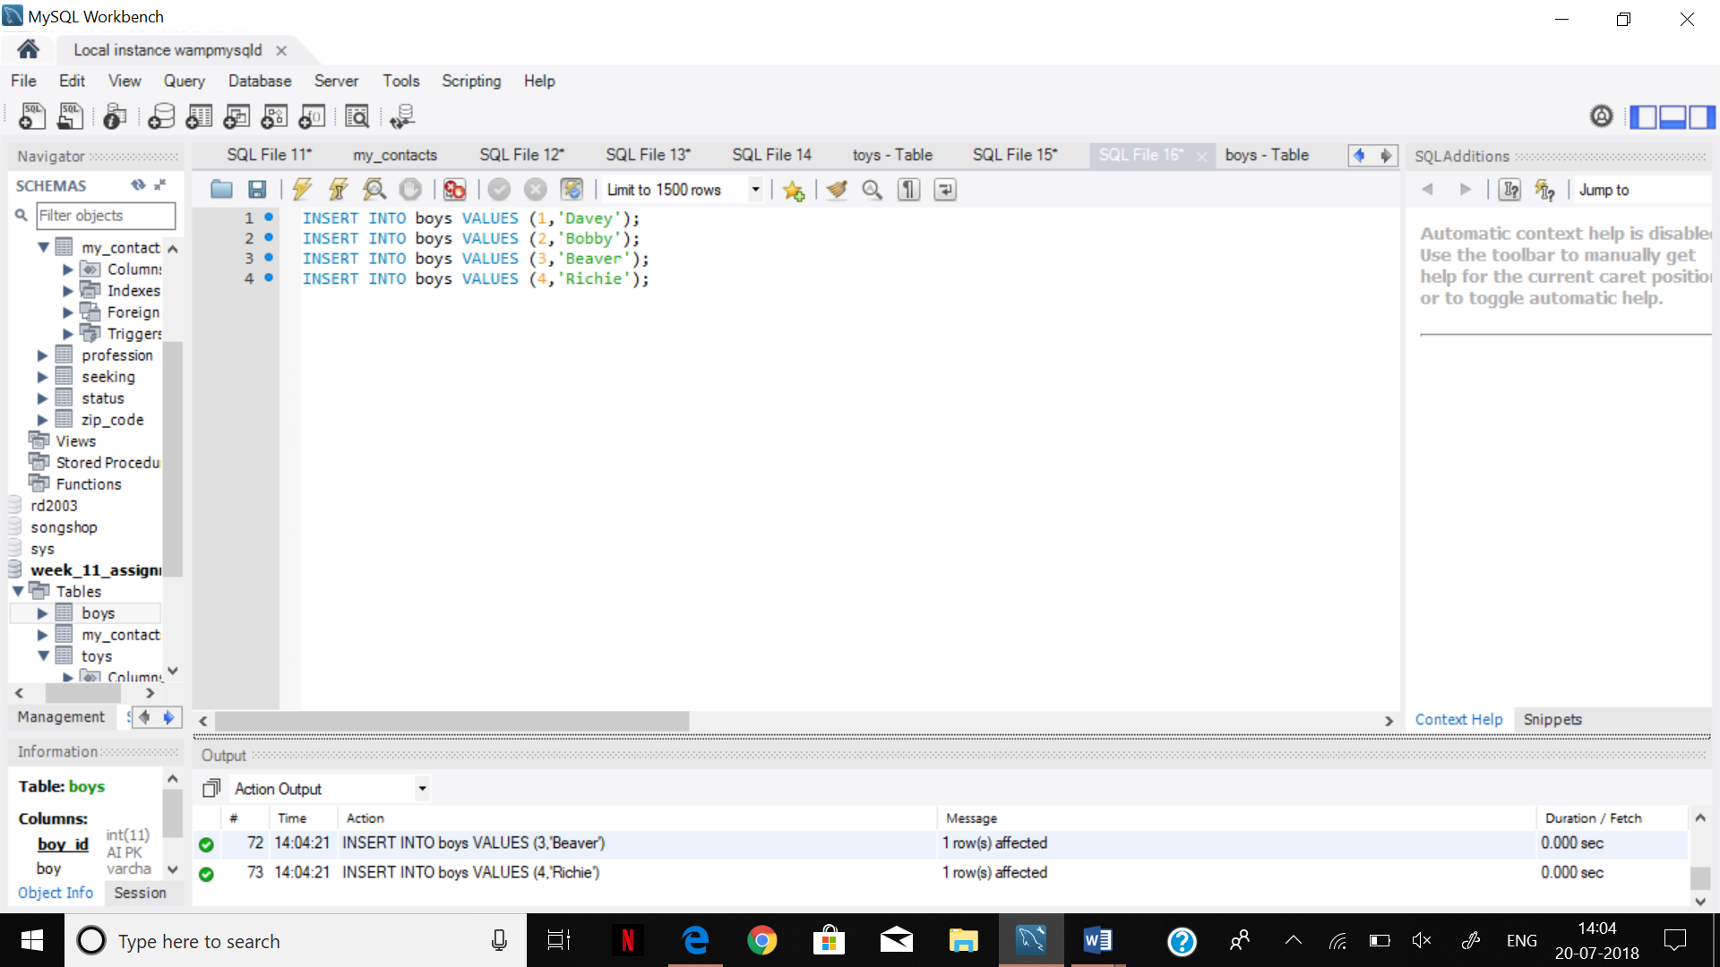

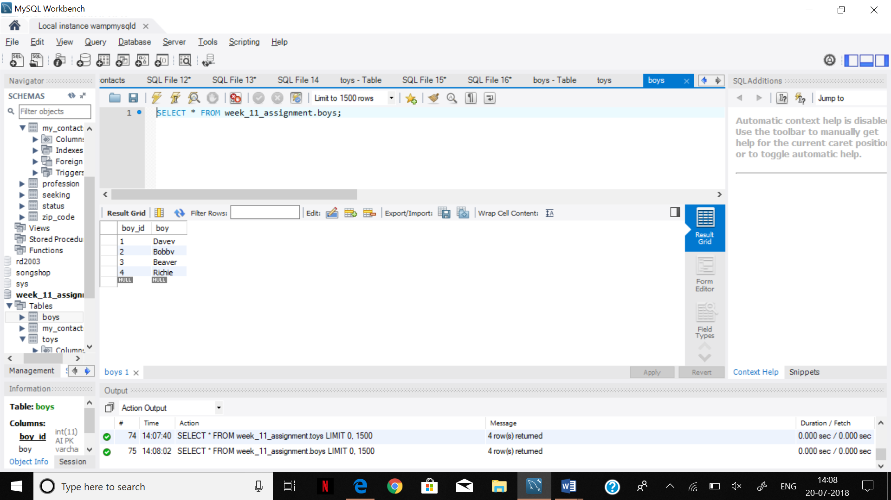

SELECT t.toy, b.boy

FROM toys AS t

CROSS JOIN

boys AS b;

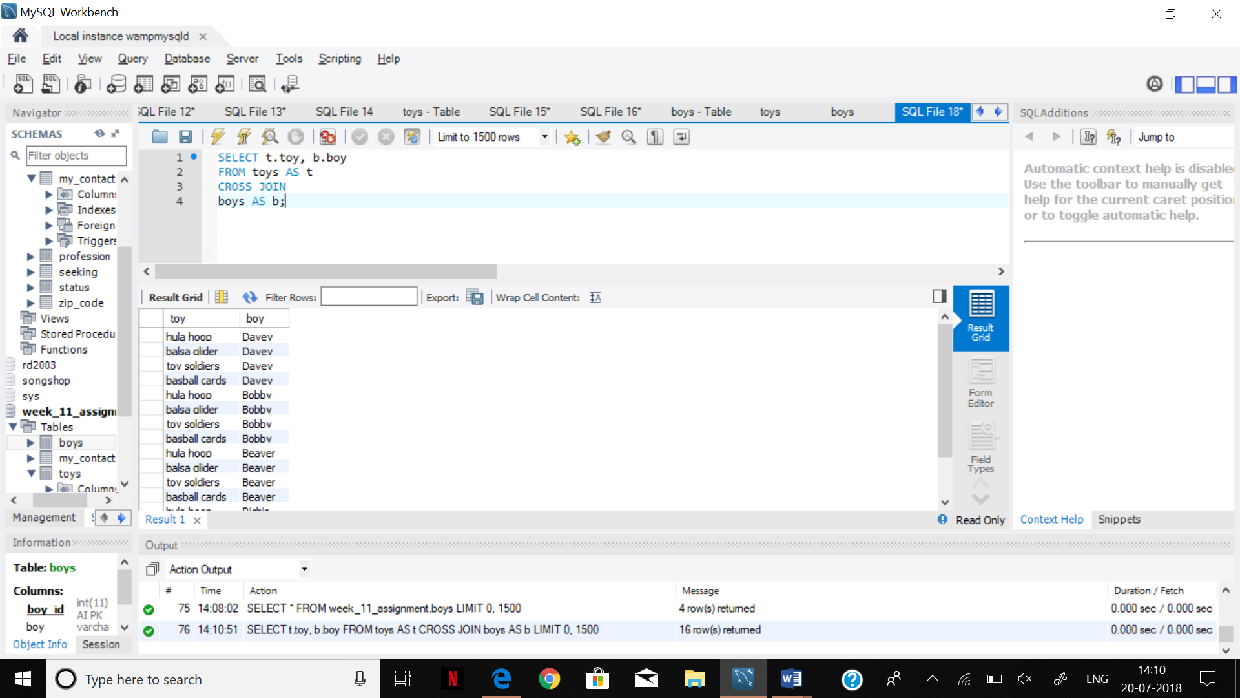

Step 11.

ALTER TABLE my_contacts ADD COLUMN prof_id INT;

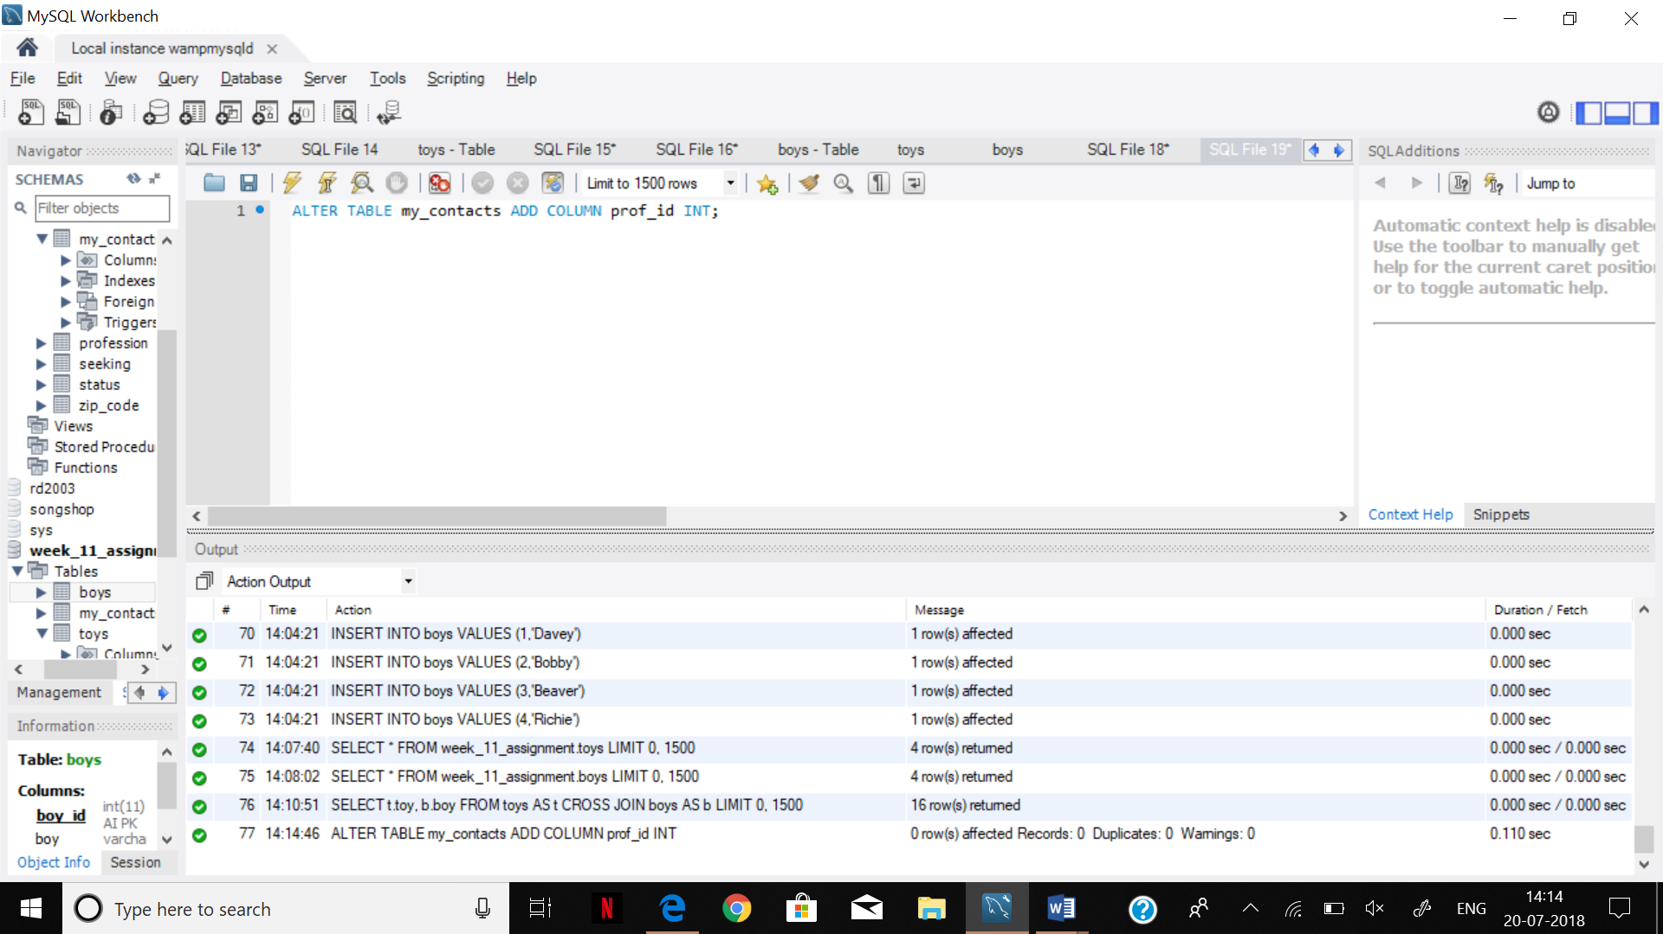

ALTER TABLE my_contacts

ADD CONSTRAINT prof_id_fk

FOREIGN KEY (prof_id)

references profession (id);

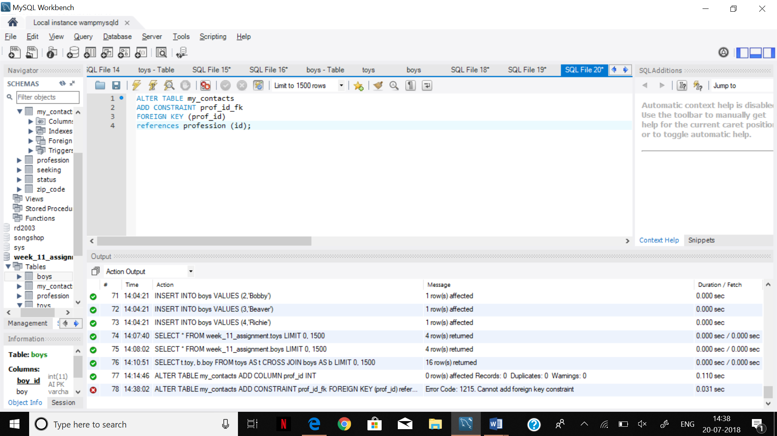

Step 12.

SELECT boys.boy, toys.toy

FROM boys

INNER JOIN toys

ON boys.toy_id = toys.toy_id;

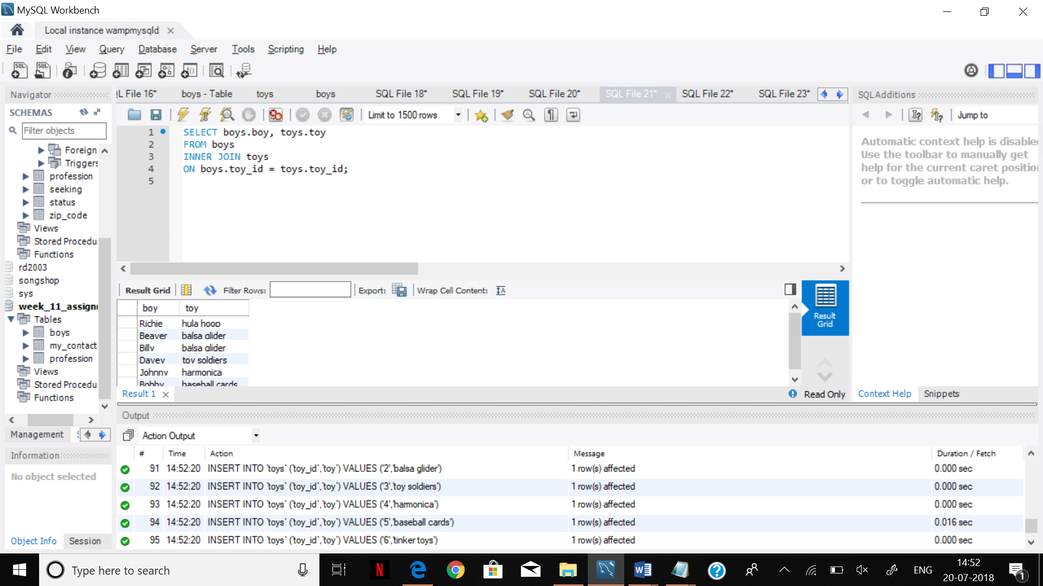

Step 13.

SELECT boys.boy, toys.toy

FROM boys

INNER JOIN toys

ON boys.toy_id <> toys.toy_id

ORDER BY boys.boy;

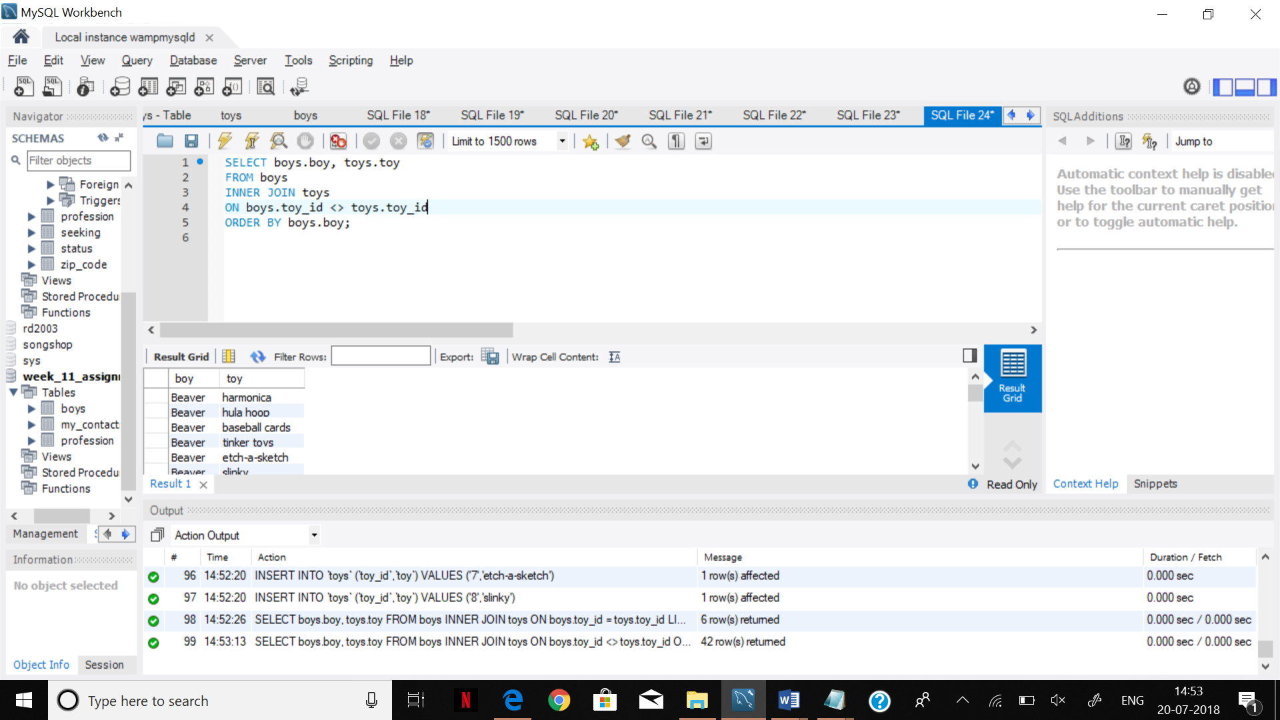

Step 14.

SELECT boys.boy, toys.toy

FROM boys

NATURAL JOIN

toys;

